**Delete an S3 Bucket**

**Step 1:** Selecting the S3 bucket you want to delete

* Choose the bucket

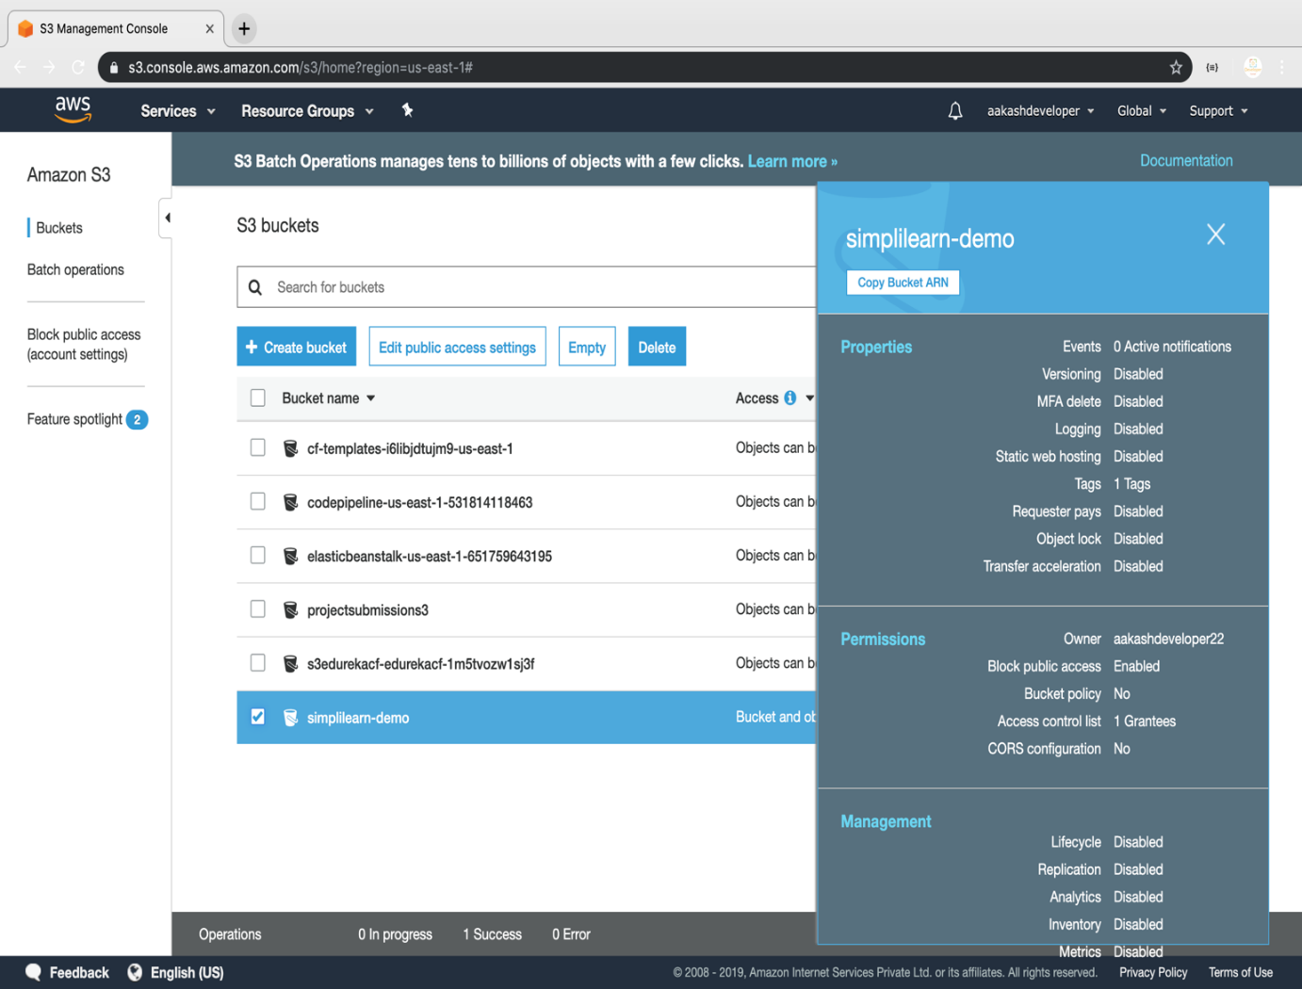

**Step 2:** Deleting the bucket

